Lab 01 - Working with ReactJS application

1. Introduction
This lab explores creating a ReactJS application by using Vite – A build tool.

2. Lab Objectives
In this lab, you will:
- Setting Up the Development Environment
- Scaffold out a starter React application using Vite – a build tool.
- Create components to display the list of Orchids
- Run the project.
3. Lab Resources
images.zip

Activity 01: Setting Up the Development Environment
Step 01. Download and install Node.js and npm
- Download Node.js from the official website: https://nodejs.org/en/download
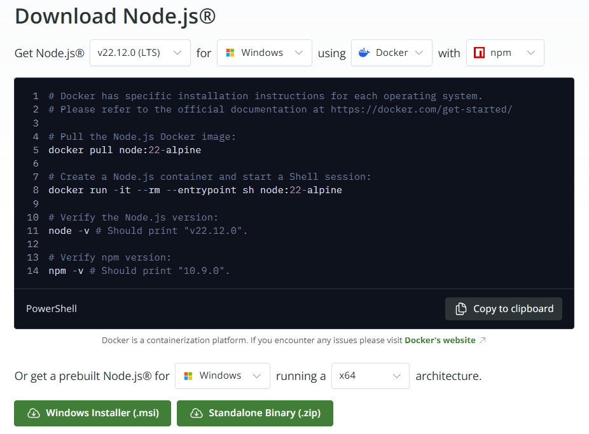
- After install successfully, check the version of Node and npm:
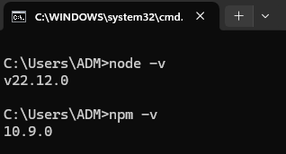

Step 02. Download and install Visual Studio Code

- Go to: https://code.visualstudio.com/Download
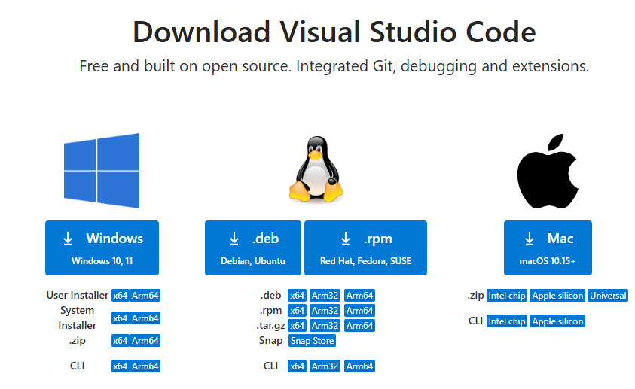
- Install VS Code Extensions for React: ES7+ React/Redux/React-Native snippets:
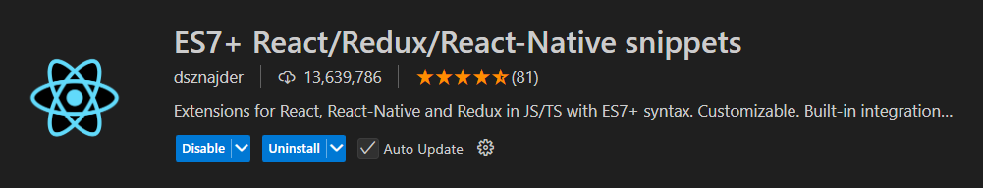

Activity 02: Scaffold out a starter React application
Step 01. Create a new folder React-01 in VS Code, using the terminal and type:
npm create vite@latest demo-01
- Select the options following the image below:
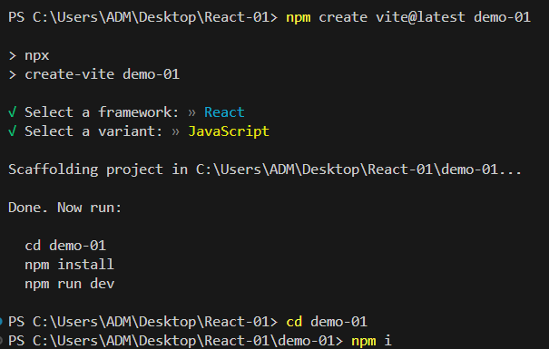
- Jump to the demo-01 folder and install the packages:
cd demo-01
npm install
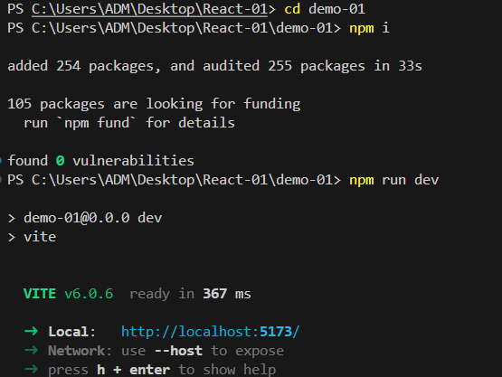

Step 02. Run the project
npm run dev

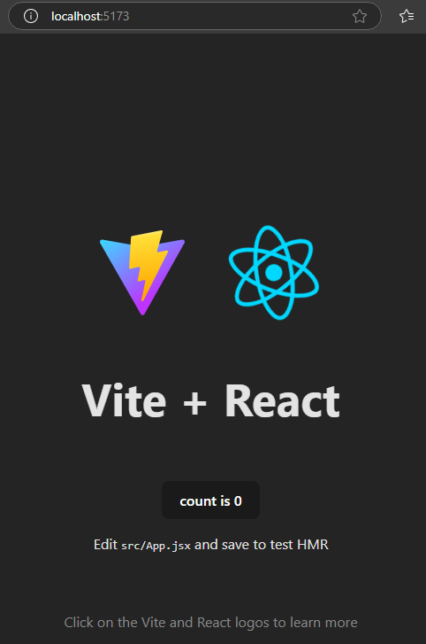
- Open the web browser, access the address: http://localhost:5173

Activity 03: Install the Bootstrap CSS and design the App component
Step 01. Install react-bootstrap and Bootstrap CSS
npm install react-bootstrap bootstrap
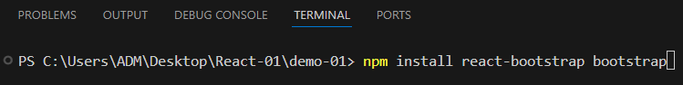
- Included CSS to your application:
{
/* The following line can be included in your src/main.jsx or App.jsx file */
}
import 'bootstrap/dist/css/bootstrap.min.css';

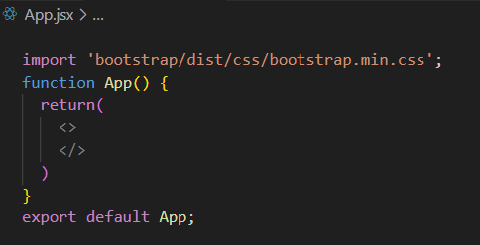

Step 01. Design the NavBar component
- Adding some code to show the NavBar
import 'bootstrap/dist/css/bootstrap.min.css';
import Container from 'react-bootstrap/Container';
import Nav from 'react-bootstrap/Nav';
import Navbar from 'react-bootstrap/Navbar';
function App() {
return(
<>
<Navbar expand="lg" className="bg-body-tertiary">
<Container>
<Navbar.Brand href="#home">Single Page Application</Navbar.Brand>
<Navbar.Toggle aria-controls="basic-navbar-nav" />
<Navbar.Collapse id="basic-navbar-nav">
<Nav className="me-auto">
<Nav.Link href="#home">Home</Nav.Link>
<Nav.Link href="#link">Link</Nav.Link>
</Nav>
</Navbar.Collapse>
</Container>
</Navbar>
</>
)
}
export default App;
- The screen will display below:
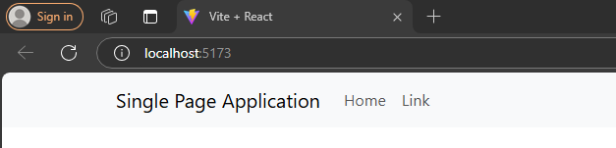

Step 02. Design the List of Orchids component
- Extract and put images folder into public folder
- Add some code to show the List of Orchids by using Card component, Students provide data for the remaining 7 columns.
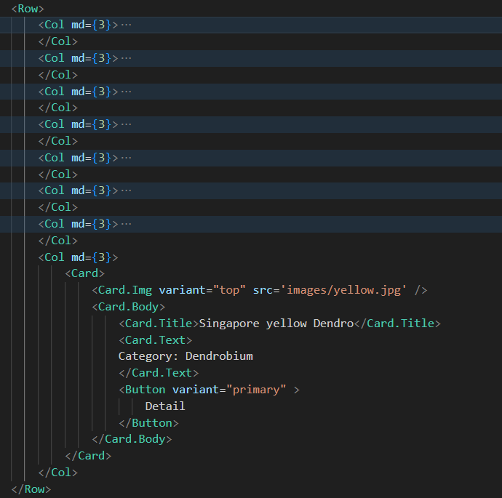

- The screen will display below:
